***Sruthi Madhusudanan***

***MGT552- Leading Through Digital Disruption***

*End-of-Course Assessment - January Semester 2023*

*Submission date : 28 April 2023*

Table of Contents

1)Artificial Intelligence 2

Artificial Intelligence in Automotive Industry 3

**Use cases of AI in automotive industry** 3

**Analysis** 6

**DOI Theory:** 7

**S Curve:** 8

**Putting it altogether – Hype Cycle + DOI + S Curve** 9

2) Toyota – A Brief History 9

Evaluation of Toyota’s Response 10

**The Adjacency Map** 10

**Kotter’s 8 step change model** 12

What does the future entail for Toyota? 13

References 13

# **1)Artificial Intelligence**

Artificial Intelligence is a branch of computer science that delas with building smart machines capable of performing tasks that typically require human intelligence. AI is an interdisciplinary science and with the advancements in Machine Learning and Deep learning, there is a paradigm shift in almost every tech sector.

Starting with the Turing test and with the most recent ChatGPT from OpenAI, AI as a technology has undergone a widespread transformation over the years. Below is a timeline infographic of AI over the years.

Fig. 1 AI Timeline

# **Artificial Intelligence in Automotive Industry**

Automotive Industry is one of the primary sectors undergoing significant disruption due to the emergence and advancements in the field of Artificial Intelligence. AI in automotive industry is changing the way we think about transportation. Size of AI in Automotive Industry has exceeded USD $6 Billion in 2022 and is projected to grow over 55% from 2023 to 2032. Increasing adoption of autonomous vehicles across the world will fuel this growth.

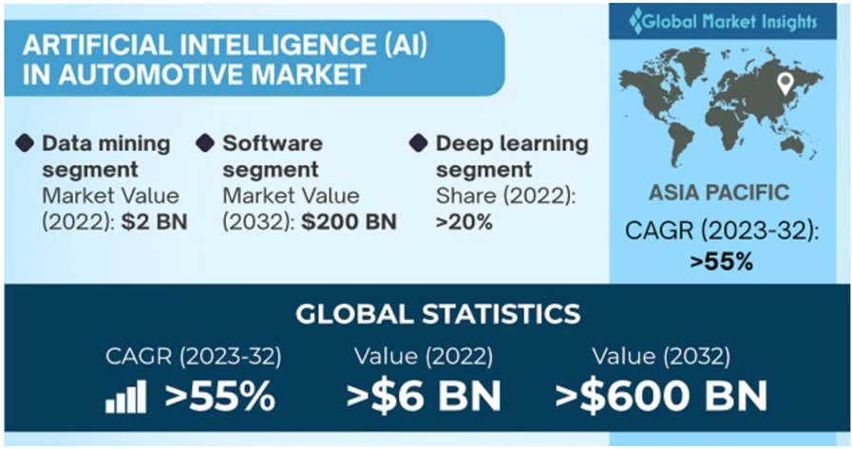

Fig. 2 Automotive AI market stats

The below figure shows the value of AI in automotive market across different regions in the world. As we can see, there is an increasing trend in the value of AI in automotive sector across the world, especially in APAC, where it’s predicted to grow by 55% by 2032.

Fig. 3 Global AI in Automotive Market By Region

## **Use cases of AI in automotive industry**

Let’s examine some of the disruptive use cases for AI in the automotive industry.

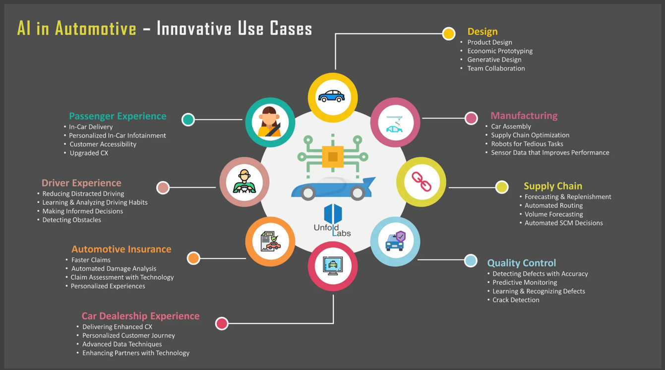

Fig. 4 Automotive AI Use Cases

**Design**

AI has been used by OEMs to speed up design workflows. Below are some use cases.

* NVIDIA accelerates design workflows by using AI, real-time ray tracing, and programmable shading to improve their traditional design process and reduce time taken for design finalization.
* General Motor’s Dreamcatcher promotes economic prototyping via Machine Learning
* Volkswagen relies on Generative Design to make their cars more compact.

Generative Design is the future of design where AI algorithms can generate design prototype based on product idea or the problem at hand.

**Manufacturing**

AI is employed in every step of car manufacturing process right from supply chain to assembly.

* Rethink robotics help optimize supply chain process by working with humans.
* Kia, in association with Hyundai developed wearable robots for performing tedious tasks.
* KONUX uses AI to optimize system performance to prevent unexpected machine failures in assembly line.

**Supply Chain**

An average vehicle has over 30K distinct parts sourced from suppliers across the globe making automotive supply chains as one of the most complex networks in the world. AI enabled supply chain help improve forecast by analyzing a huge amount of data.

* Blue Yonder optimize their forecasts and replenishments using AI driven techniques. This also helps them better manage their pricing.

**Quality Control**

Quality control is a tedious process and error prone. Employing AI for such tasks helps detect defects efficiently.

* Audi uses machine learning to identify even the minutest of cracks in metal parts.

**Automotive Insurance**

Another industry on the verge is automotive insurance. AI driven solutions can considerably speed up the filing & claims.

* Ant Financial uses machine learning to analyse vehicle damage and process claims
* Ping uses AI to automate claims using a credit-based auto insurance solution

**Driving Automation**

Advance Driver Assistance Systems (ADAS) helps assisting drivers on numerous activities like parking, hands free phone calls, automatic door lock to name a few. They also collect valuable insights about the driver, vehicle, passenger and driving habits to make informed decision.

* Ford, Mazda, Benz etc. are using steering input and directions to develop Driver Attention Alerts

Automated Driving Systems (ADS) technology on the other hand is an advancement over ADAS, where the vehicle can be operated with limited or no human interaction.

All big OEMs like Tesla, BMW, Daimler, Toyota, Ford, Volvo, Audi to name a few have invested heavily in autonomous vehicles.

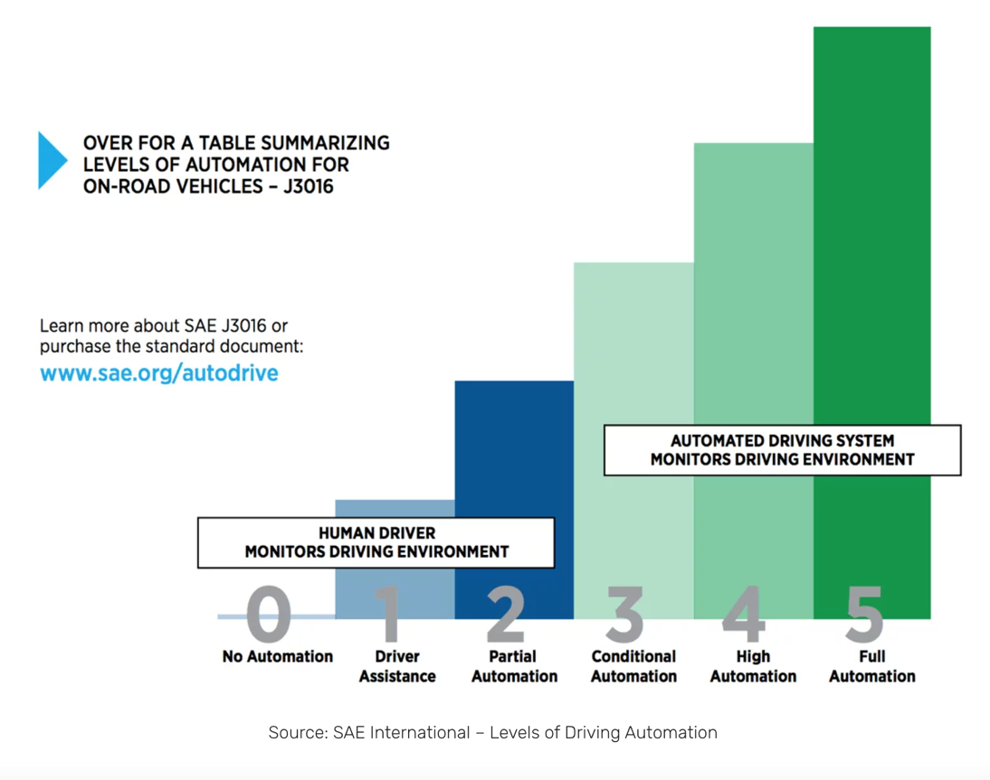

Fig. 5 Levels of Driving Automation

## **Analysis**

In this analysis, we will examine the disruption caused by AI in the automotive industry using the Hype Curve, DOI theory, and S Curve frameworks.

**Hype Curve:**

The Hype Curve is a framework developed by Gartner that helps to understand the lifecycle of emerging technologies. According to Gartner there are five stages in the lifecycle of emerging technology.

* Innovation Trigger - Potential tech breakthrough
* Peak of Inflated Expectations - Initial publicity, success stories & failures
* Trough of Disillusionment - Waning interests with failed implementations
* Slope of Enlightenment – Interest from enterprises and funds for pilots
* Plateau of Productivity – Mainstream adoption kicks off.

Hype curve helps track the journey of new technologies from “Innovation Trigger” phase to “Plateau of Productivity”.

As per Gartner’s Hype cycle for Connected Vehicles and Smart Mobility 202, most of the technologies in this space are at **“Trough of Disillusionment”,** which is a positive sign. This means that most of these technologies are on the verge of getting commercialized. Over the next 5-10 years many of the technologies will become an integral part of automotive and smart mobility ecosystem. However, with technologies becoming mature, companies are also facing implementation struggles and to bridge the gap between reality and promised benefits leading most companies to focus on practical applications. That being said, AI in automotive industry is well on track to reach the "Plateau of Productivity", with the major hype driven by the promise of autonomous vehicles, which have the potential to reduce accidents, increase efficiency, and transform the way we think about transportation.

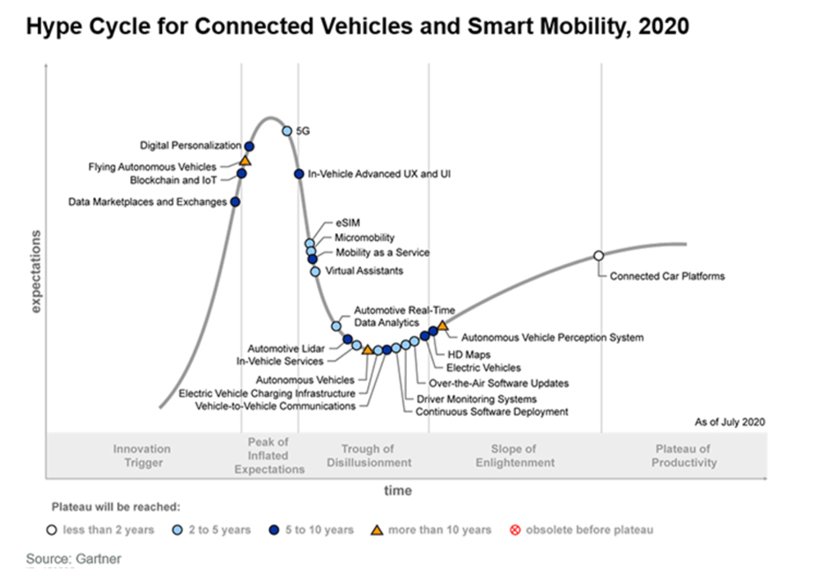

Fig. 6 Hype Cycle for Connected Vehicles and Smart Mobility

**DOI Theory:**  
  
The DOI (Diffusion of Innovations) theory is a framework that explains how and why new products and technologies are adopted by individuals and organisations. Adoption means a person is willing to perceive a new & innovative idea or product and ready to do something different than what they had done previously. DOI theory has five adopter categories.

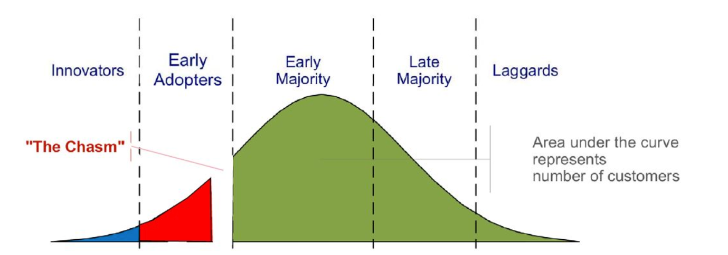

Fig. 7 DOI curve

Innovators: Innovators are organisations who are willing to take risks and experiment with new ideas and create breakthroughs. In the automotive industry, companies like Tesla and Waymo has been working extensively on AI technologies like ADS and have made a significant progress over the years.

Early adopters: Early adopters well-respected and influential organisations who doesn’t hesitate to adopt new technologies after the innovators. In the automotive industry, companies like GM ( ~$3.5billion) and Ford ( ~$7billion) have invested heavily in autonomous vehicles and are part of early adopters.

The Chasm: There is a gap or "chasm" between early adopters and early majority that requires a significant effort or external shock to cross.

Early majority: Following Early adopters are Early majority who forms the largest group. They are generally risk averse and wait for more evidence before adopting. Toyota and Honda are examples of Early majority as they risk conscious but still have incorporated AI in their tech.

Late majority: This is a group of organisations who play the waiting game and adopts technologies when they become mainstream. Volkswagen and BMW who are still in the process of developing and testing AI technologies belong to this space.

Laggards: Laggards are the last group who fails to adopt new technologies due to lack of knowledge or interest. In the automotive industry, laggards include smaller manufacturers who lack the resources to invest in AI technologies.

### **S Curve:**

The S Curve is a framework that projects the adoption rate of a new technology over time. It tracks the rate of adoption from the early stages of adoption to the point where the technology becomes ubiquitous. S Curve has three phases.

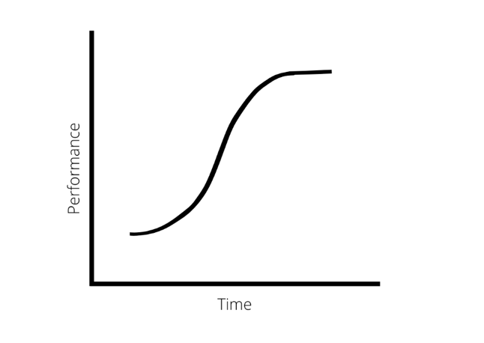

Fig. 8 S Curve

* Ramping – New technology gains transaction
* Scaling – Technology is still early with scientists and researchers making rapid progress.
* Plateau – Technology becomes ubiquitous.

I With respect to automotive industry, adoption is driven by the potential benefits of AI, including increased efficiency, reduced accidents, and a shift towards autonomous vehicles. we are currently at the beginning of scaling phase where the technology is still in its early days and good progress being made. A lot of effort is put on this stage to make the best technology possible in order to account for future scaling.

### **Putting it altogether – Hype Cycle + DOI + S Curve**

Hype Cycle, DOI and S Curve are complimentary concepts that can be linked together. If we overlay these concepts for the disruption of AI in automotive industry, we come up with a result like below.

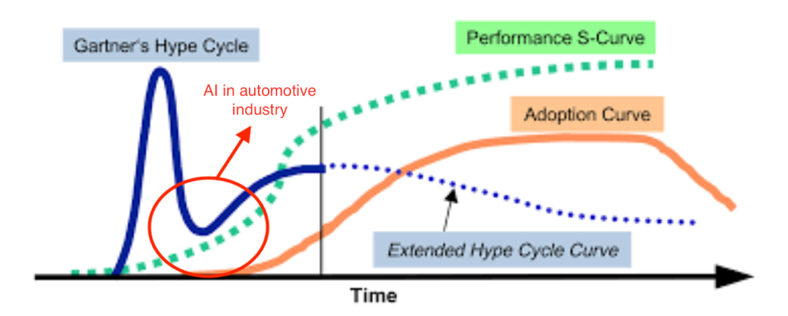

Fig. 9 Hype Cycle + DOI + S Curve

|  |  |  |
| --- | --- | --- |
| **AI in Automotive Industry** | | |
| **Framework** | **Stage** | **Description** |
| Hype Cycle | Trough of Disillusionment | AI in automotive industry is still on early days but well on track to reach the plateau |
| DOI | The Chasm |
| S Curve | Ramping |

# **2) Toyota – A Brief History**

Toyota, located in Aichi in Japan, is the single largest automobile manufacture in the world. They are the 13th largest corporation in terms of revenue in the world. Toyota did not start as a car manufacturer. Infact they invented the first automatic loom in the world and was started as Toyoda Spinning and Weaving Company. It was only in 1933, Toyota automobiles was formed. As of 2021, Toyota’s market cap exceeds $250 billion.

With a global presence in over 170 countries, Toyota is one of the major players to be impacted by the AI disruption in the automotive industry. Adapting to the AI disruption in the automotive industry is a critical challenge for Toyota. In order to sustain their place as the industry leader, Toyota must stay agile and stay ahead of the curve by being innovative.

In order to keep pace with the disruptive technologies, Toyota established Toyota Research Institute (TRI) in 2015. The primary goal for this was to develop active efforts in disruptive areas like ADS, robotics to name a few. In 2017, TRI has invested over $100 million to launch Toyota AI ventures, which is another subsidy of Toyota that provides early-stage finance to startups focusing on AI, autonomous mobility and robotics. Toyota AI ventures started with investments on three startups namely SLAMcore, Nauto and Intuition robotics. Since then , with over $200 million in management funds, Toyota AI ventures has invested in 36 startups reflecting the growing adoption of AI and Toyota’s commitment to ride the AI wave.

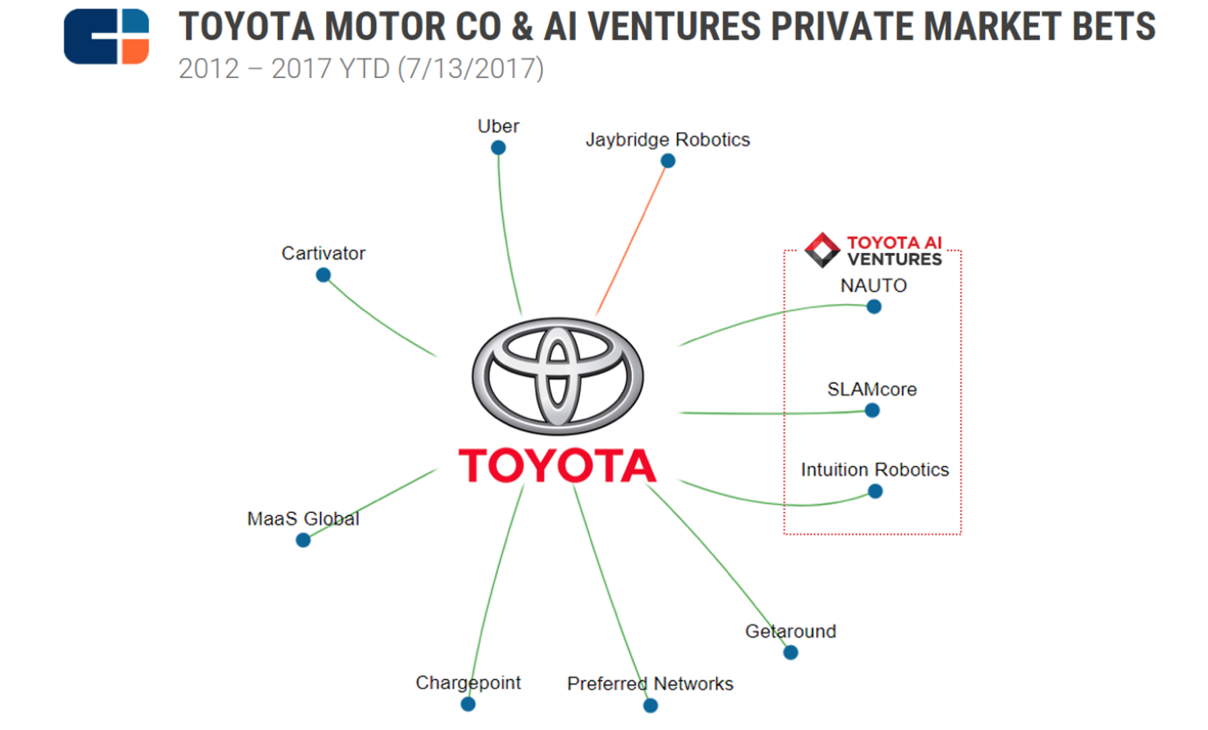

Fig. 10 Toyota Ventures

# **Evaluation of Toyota’s Response**

We will be using two frameworks to evaluate how Toyota could respond to this AI disruption.

1. The Adjacency Map
2. Kotter’s 8 step change model

## **The Adjacency Map**

The adjacency map is a strategic tool using which organizations can use to identify potential growth opportunities and innovation in adjacent markets or lines of business. The process starts with identifying the core business of the organization and then mapping out various industries and technologies where the organization could try expanding leverage their core capabilities.

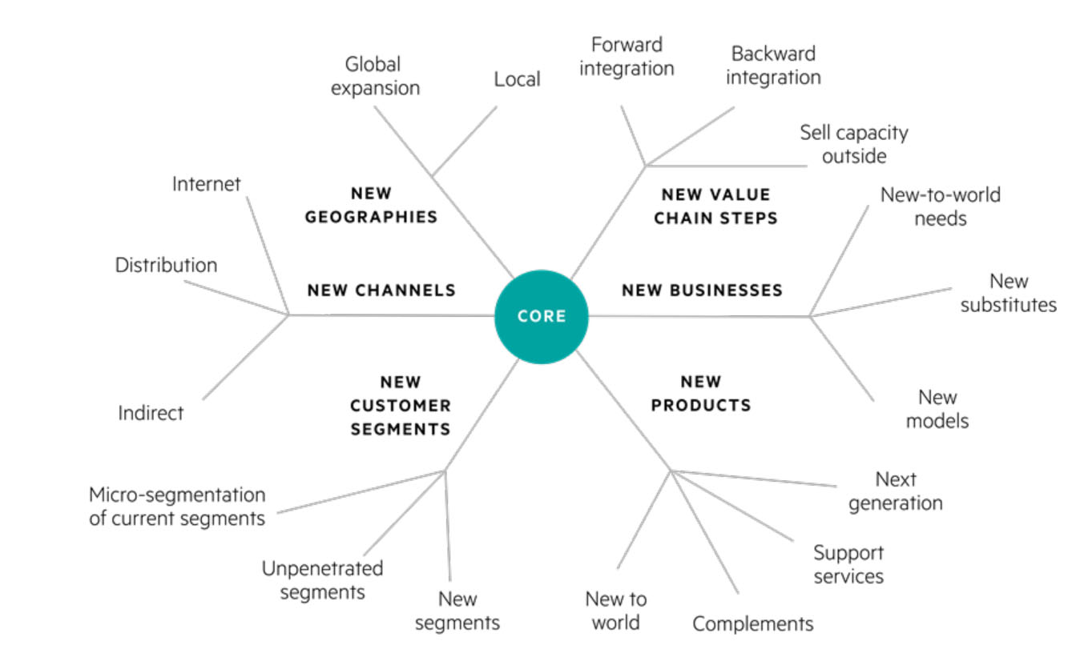

Fig. 11 The Adjacency Map

In the context of Toyota, we can the adjacency map to identify adjacent markets or opportunities where AI can be incorporated into their business model. Toyota can consider the following adjacent markets which is an extension of their core.

**Autonomous driving:**

Most of the hype surrounding automotive AI is around autonomous vehicles. Toyota can leverage their rich history as world leading manufacturer of automobiles and develop AI powered autonomous vehicles. Already most of Toyota’s competitors are investing heavily on autonomous vehicles. So investing in Autonomous vehicles can help Toyota expand their market share and keep pace with the competitors. Toyota has already started investing in autonomous vehicles via Nauto & other ventures through the Toyota AI ventures and through Mobile Teammate Concept.

**Predictive maintenance:**

One of the other ways that Toyota can incorporate AI is for predict maintenance and to optimize their supply chain and production process. This can help Toyota improve their operational efficiency. Toyota has already taken a step in this regard with Toyota Motor North America (TMNA) partnering with Invisible AI, A computer vision company to boost factory efficiency. This solution will be deployed in 14 factories in North America and will help uncover technical issues invisible to the human eye.

**Inventory Management & Supply chain optimization:**

Another area Toyota can use AI to optimize its supply chain and logistics operations. This can help Toyota reduce costs, improve delivery times, improve forecast and increase customer satisfaction. In 2021, Fujitsu and Toyota conducted a joint trial using Fujitsu’s Quantum-Inspired Digital Annealer Computing Technology to optimize their supply chains in Japan. Leveraging Fujitsu’s Annealer Toyota was able to optimize 3 million Potential Routes and reduce logistics cost by 2-5%.

## **Kotter’s 8 step change model**

Kotter’s 8 step change model is a change management framework developed by Jon Kotter, A Harvard business professor. This model is a widely used step-by-step framework for effective organization change across various organization and industry. We will use this model to explain how Toyota can plan for the implementation of the opportunities in The Adjacency Map and AI disruption as a whole.

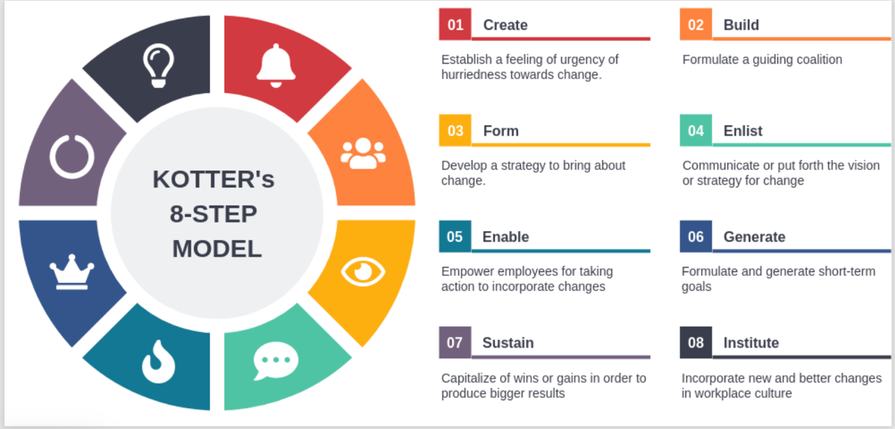

Fig. 12 Kotter’s 8 Step Change Model

**Establishing a sense of urgency**: First and foremost, Toyota needs to understand the importance of creating adjacent business lines such as autonomous driving, predictive maintenance, and inventory management and supply chain optimization to stay competitive and meet ever changing customer demands.

**Creating a guiding coalition**: Toyota should set up an expert team specializing across different domains such as engineers, data scientists, logistics experts, analysts, marketing specialists, change management specialists etc., to lead the implementation.

**Developing a vision and strategy:** Toyota should clearly define their vision and strategy for AI disruption and how it will align to the overall mission and goals of the company.

**Communicating the change vision:** Toyota needs to communicate the vision and strategy for implementing these adjacent business operations to its employees, stakeholders, and customers to ensure everyone understands the benefits and importance of the change.

**Empowering employees for broad-based action:** Toyota should plan upskilling for their employees through training and provide resources to work with disruptive technologies and promote a culture of experimentation and innovation.

**Generating short-term wins:** Toyota should focus on gathering quick wins such as implementing autonomous driving features in its vehicles, predictive maintenance improvement to reduce downtime, and inventory optimization to improve operational efficiency.

**Consolidating gains and producing more change:** Toyota should leverage on the successfully history and continue to build these adjacent business opportunities to move the needle in areas like customer satisfaction, cost reduction and operational efficiency.

**Anchoring new approaches in the organization's culture:** In order to stay ahead of the competition, Toyota must think long term to ensure the sustainability of the changes. To achieve this, Toyota should embed the adjacent opportunities and AI disruption part of their corporate culture.

# **What does the future entail for Toyota?**

In 5-10 years, Toyota's response to the AI disruption would have made a significant shift in the company's business model and operations. Toyota will now have a more advanced, efficient and safe vehicle fleet thanks to the successful implementation of autonomous driving features. In addition to traditional vehicles, Toyota will now have the capabilities to expand into new territories like autonomous taxis. With their advancement in predictive maintenance technologies, Toyota will have reduced downtime and improved operational efficiency leading to cost savings and improved customer satisfaction. With improved inventory management and supply chain optimization, Toyota can further reduce costs making them even more competitive in the market. Toyota may also consider strategic partnerships and investments in new technologies to improve efficiency.

Overall, in 5-10 years, Toyota will likely be a more advanced, efficient, and customer-focused organization, with a stronger focus on technology and innovation. Toyota may also expand into new areas to take advantage of new business opportunities.

# **References**

Schroer, A. (3 March , 2023). Artificial Intelligence. What Is Artificial Intelligence (AI)? How Does AI Work? . Retrieved from https://builtin.com/artificial-intelligence

Marsden, D. P. (21 August, 2017). Artificial Intelligence Timeline Infographic – From Eliza to Tay and beyond. Retrieved from https://digitalwellbeing.org/artificial-intelligence-timeline-infographic-from-eliza-to-tay-and-beyond/

Preeti Wadhwani, S. L. (2022). Artificial Intelligence (AI) in Automotive Market. Global Market Insights .

Ashok, A. (7 March, 2020). AI & Automotive — 8 Disruptive Use-Cases. Retrieved from https://unfoldlabs.medium.com/ai-automotive-8-disruptive-use-cases-fd079926aea9

Faggella, D. (14 March, 2020). The Self-Driving Car Timeline – Predictions from the Top 11 Global Automakers. Retrieved from https://emerj.com/ai-adoption-timelines/self-driving-car-timeline-themselves-top-11-automakers/

Paul Gao, H.-W. K. (1 January, 2016). Disruptive trends that will transform the auto industry. Retrieved from https://www.mckinsey.com/industries/automotive-and-assembly/our-insights/disruptive-trends-that-will-transform-the-auto-industry

SEA. (11 September, 2020). The annual Gartner Hype Cycle tracks emerging automotive technologies such as digital personalization. Retrieved from https://www.sae.org/news/2020/09/2020-hype-cycle-for-connected-vehicles-and-smart-mobility

David Shepardson, H. J. (19 March, 2022). GM bets $3.5 billion more on self-driving tech unit as SoftBank exits. Retrieved from https://www.reuters.com/business/autos-transportation/gm-buys-softbank-vision-funds-stake-cruise-21-bln-2022-03-18/.

Ben Klayman, P. L. (5 Febraury, 2021). Ford boosts investment plan for EVs and self driving vehicles, reports loss. Retrieved from https://www.reuters.com/article/us-ford-motor-results-idUSKBN2A42VN

owen, R. (24 December , 2021). Artificial Intelligence at Toyota. Retrieved from https://emerj.com/ai-sector-overviews/artificial-intelligence-at-toyota/

Clifford, J. (11 July, 2017). Toyota to fast-track disruptive tech with Toyota AI Ventures. Retrieved from https://mag.toyota.co.uk/toyota-to-fast-track-disruptive-tech-with-toyota-ai-ventures/

Leopold, G. (12 March, 2021). Toyota Investment Fund Driving New Investments in AI-based Robotics. Retrieved from https://www.enterpriseai.news/2021/03/12/toyota-fund-drives-ai-based-robotics-smart-cities-apps/

https://www.cbinsights.com/research/toyota-ai-ventures-startup-investments/. (14 July, 2017). Retrieved from AI, Robotics Dominate Toyota’s Startup Investment And M&A Bets.

Jin, H. (8 April, 2022). Retrieved from Like Tesla, Toyota develops self-driving tech with low-cost cameras: https://www.reuters.com/business/autos-transportation/toyota-joins-tesla-developing-self-driving-tech-with-low-cost-cameras-2022-04-06/

Automated Driving. (n.d.). Retrieved from https://www.toyota-europe.com/innovation/zero-accidents/automated-driving#:~:text=First%20and%20foremost%2C%20Toyota%20is,is%20safe%2C%20accessible%20and%20convenient

Artificial Intelligence Based Future Logistics by Toyota. (18 May, 2019). Retrieved from https://www.supplychaintoday.com/artificial-intelligence-based-future-logistics-toyota/

Kotter’s 8 step Model of Change. (n.d.). Retrieved from https://www.managementstudyguide.com/kotters-8-step-model-of-change.htm

(n.d.). Retrieved from A brief history of Toyota: From Toyoda Spinning and Weaving to Artificial Intelligence: https://www.osv.ltd.uk/brief-history-toyota-toyoda-spinning-weaving-artificial-intelligence/https://www.osv.ltd.uk/brief-history-toyota-toyoda-spinning-weaving-artificial-intelligence/